AWS DOCUMENTATION
Host the App
1)Launch Instance with Setting Security Group
Step I : Launch the Instance with adding two rules in Security group .Add Custom TCP : 8080 and MYSQL/Aurora :3306.
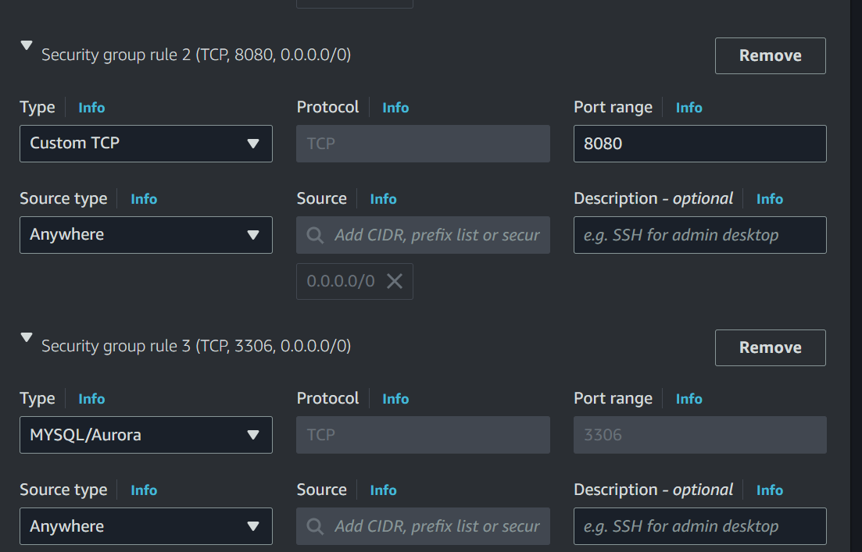
Step II : Then Launch Instance and connect it.
2)Set up the Apache Tomcat and Deploy Application.
Step III : Download Apache Tomcat using “curl -O https://dlcdn.apache.org/tomcat/tomcat9/v9.0.87/bin/apache-tomcat-9.0.87.zip” this command.
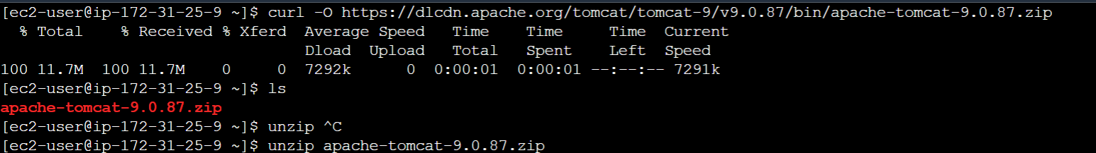
Step IV : then, unzip it.
Step V : Download Student Application file using “curl -O https://db-tom.s3.ap-northeast1.amazonaws.com/student.war” this command.
Step VI : and then move this file in webapps directory using ““mv student.war apache-tomcat-9.0.87/webapps/” this command.
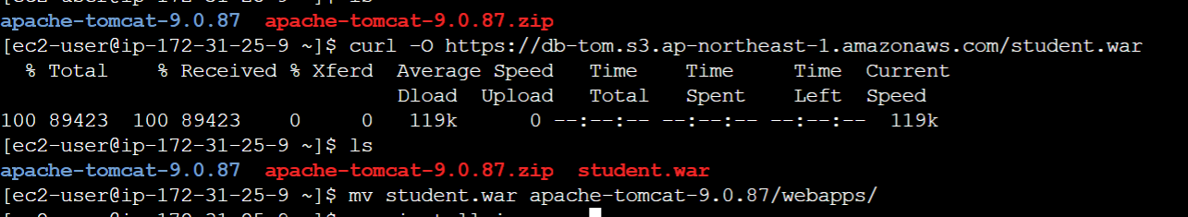
Step VII : We need Java for Tomcat to work,so install java using “yum install java -y” command.
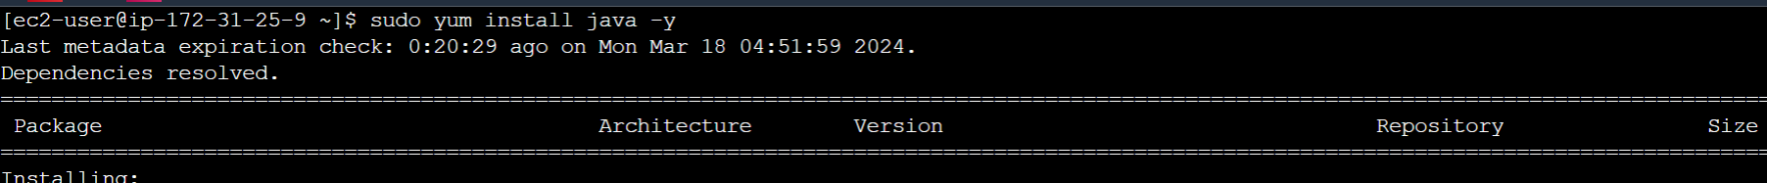
Step VIII : then,we need to give permission to catalina.sh .
Step IX : for this “ chmod 777 apache-tomcat-9.0.87/bin/catalina.sh”using these command to give the execute permissions.
Step X : After giving the permissions ,Start the catalina using “./apache-tomcat-9.0.87/bin/catalina.sh start” these command.
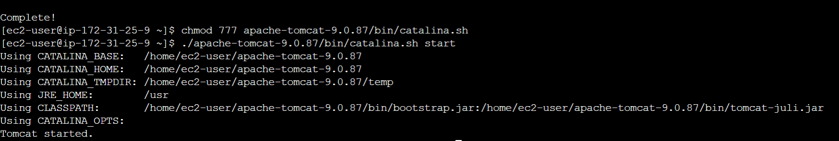
Step XI : then go to instances, copy the public ip of these Instance and paste it in other browser.
Step XII : and after IP add “:8080/student”.
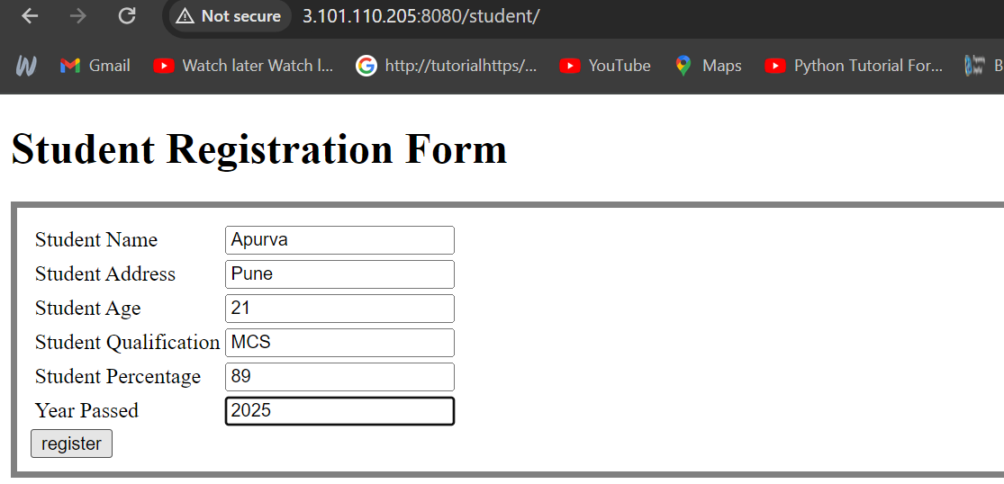
Step XIII : See here, after registering the data it is unable to save.
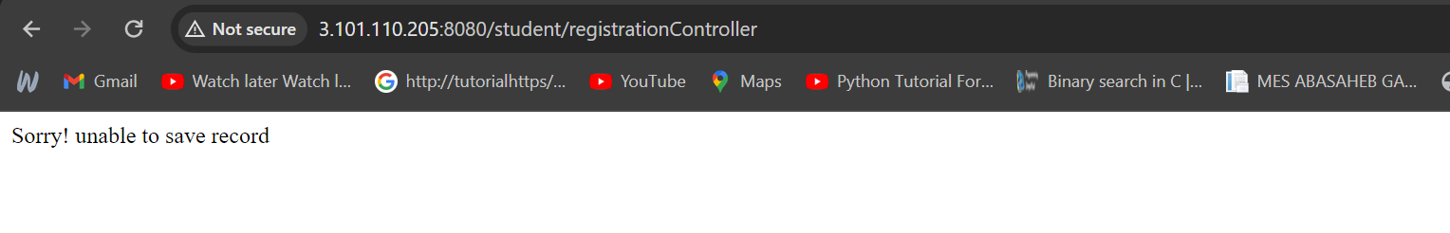
3)Set up the database
Step I : to save the data permanently we need to create database.
Step II : go to the RDS service and click on databases.
Step III : then, create database .
Step IV : Select the Standard create,Engine type is MYSQL, select the free tier template .
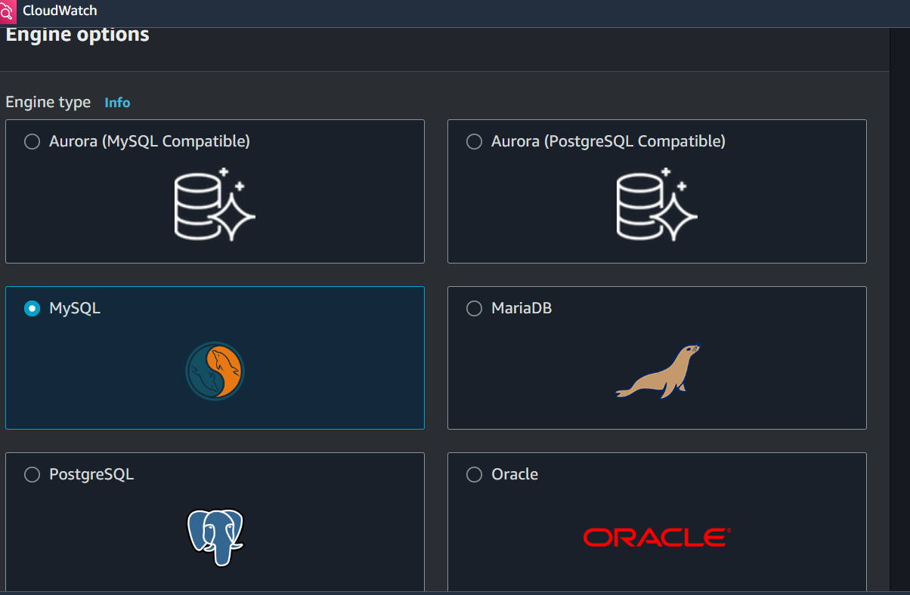
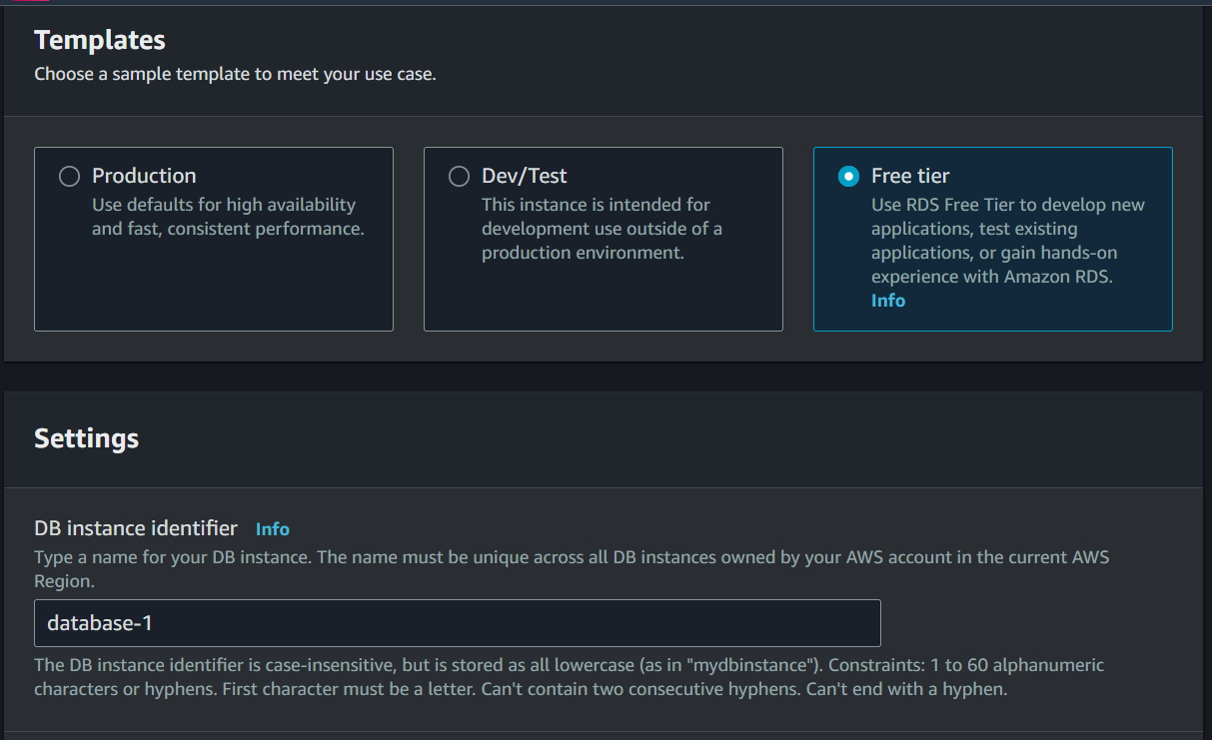
Step V : then,enter the name for DB instance, username as a admin and give the Password for database.
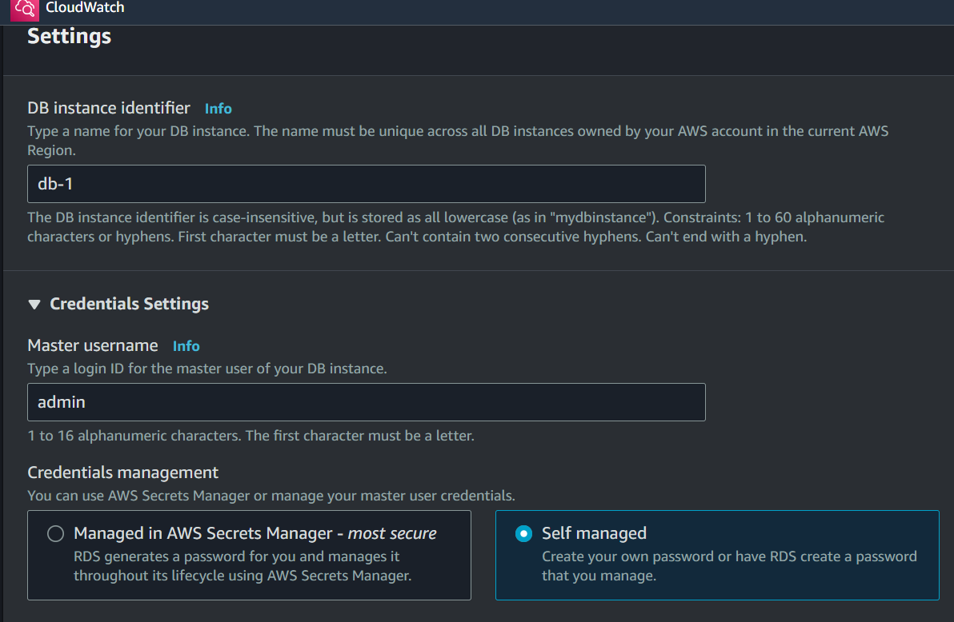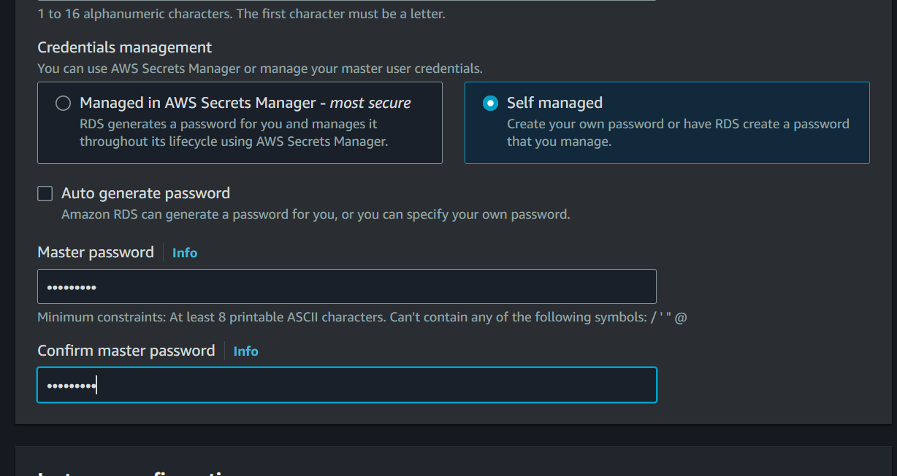
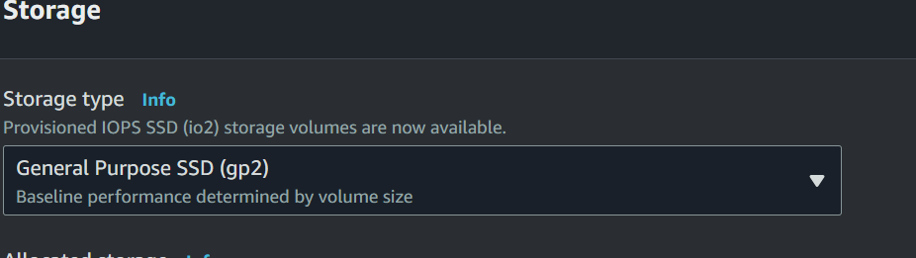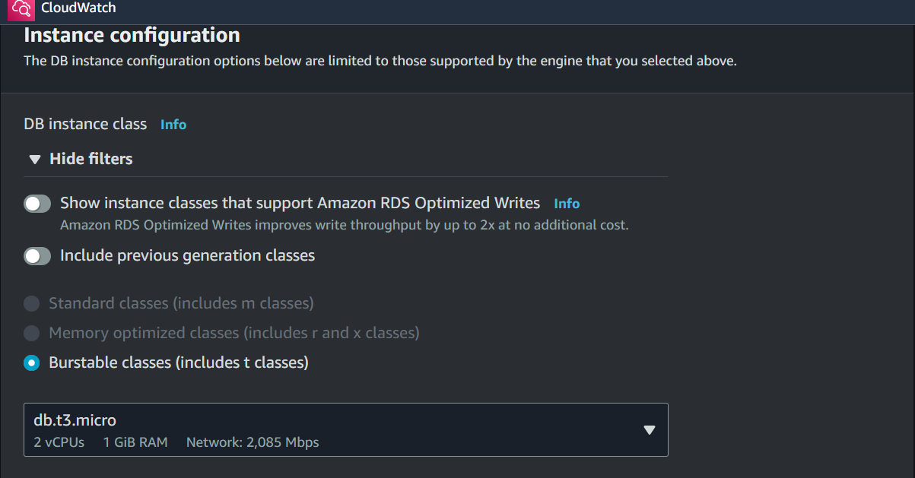
Step VI : then ,uncheck the storage auto scaling option.
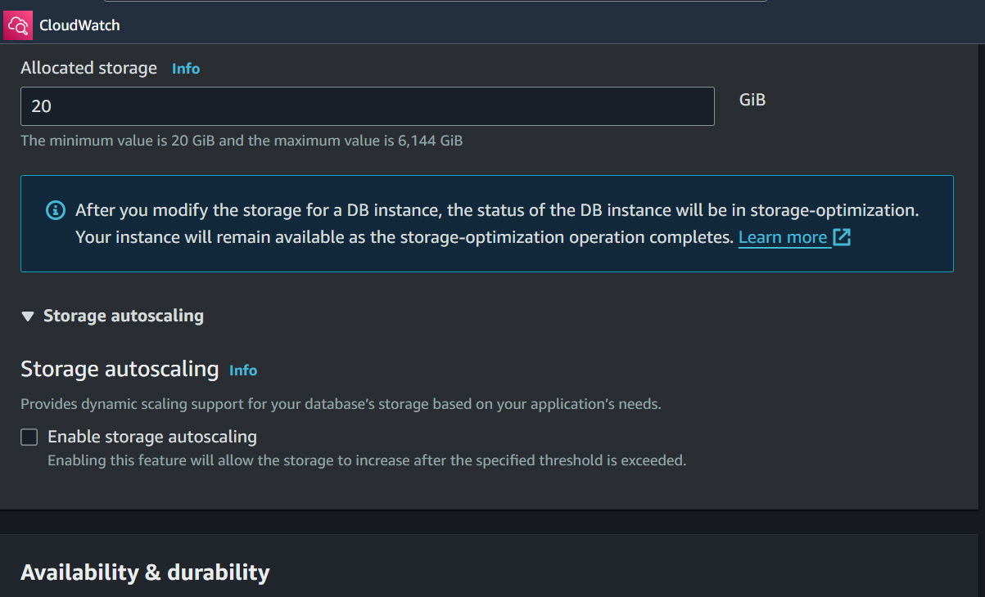
Step VII : then choose security group which we used in instance.
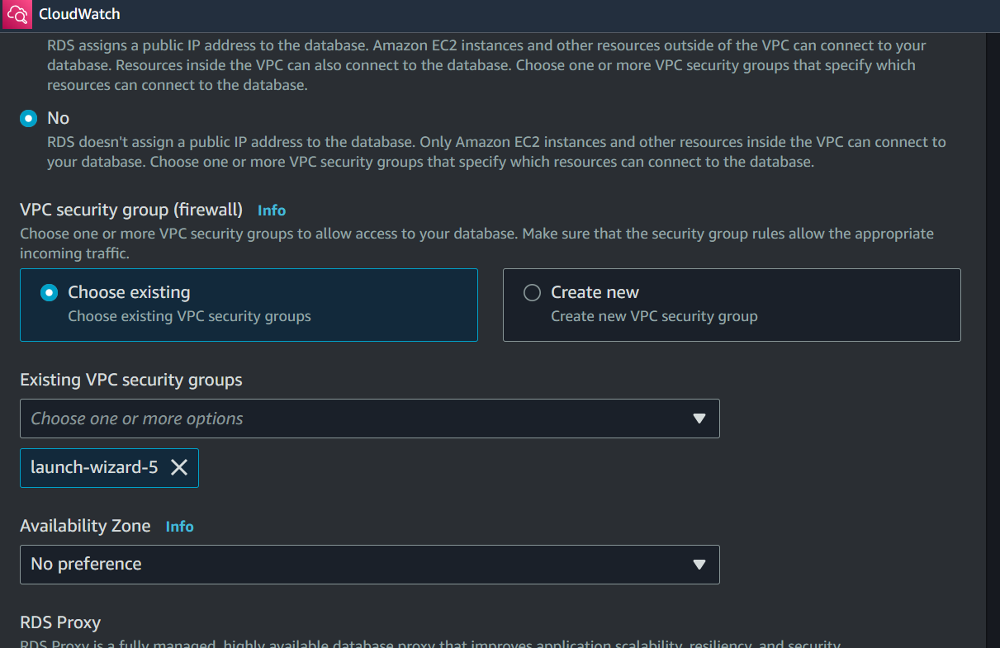
Step VIII : then uncheck the Enable automated backups and encryption,auto minor version upgrade and click on create database.
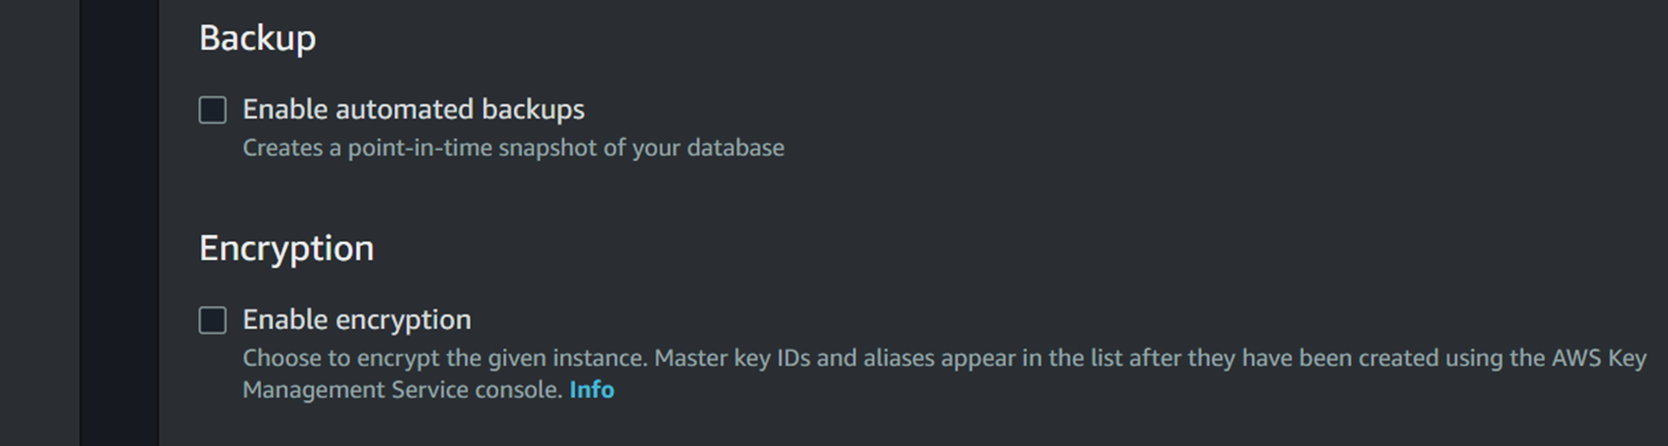
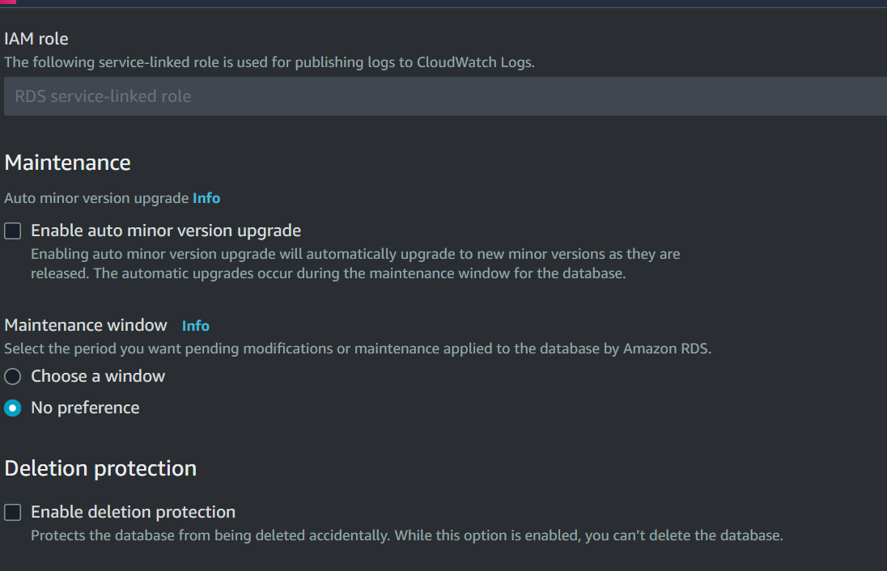
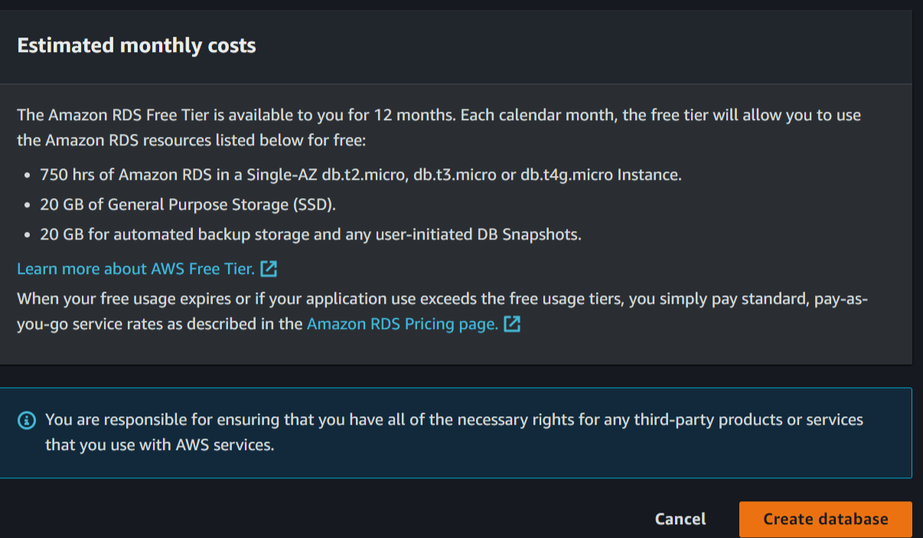
Step IX : see here, database is generated.
4)Configure Tomcat to connect to RDS .
Step I : for connecting we need to MYSQL connector to connect database.
Step II : for downloading MYSQL connector give these command “curl -O https://db-tom.s3.ap-northeast1.amazonaws.com/mysql-connector.jar”.
Step III : Move these file in the lib directory in apache – tomcat, using these “mv mysql-connector.jar apache-tomcat-9.0.87/lib/” command.
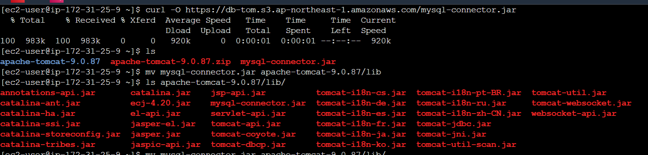
Step IV : then edit the tomcat context.xml to add RDS data Configuration in it.
Resource name="jdbc/TestDB" auth="Container" type="javax.sql.DataSource" maxTotal="100" maxIdle="30" maxWaitMillis="10000" username="admin" password="anvi1234" driverClassName="com.mysql.jdbc.Driver" url="ENDPOINT /DATABASE_NAME"/> • After making the changes in context.xml save the file and exit.
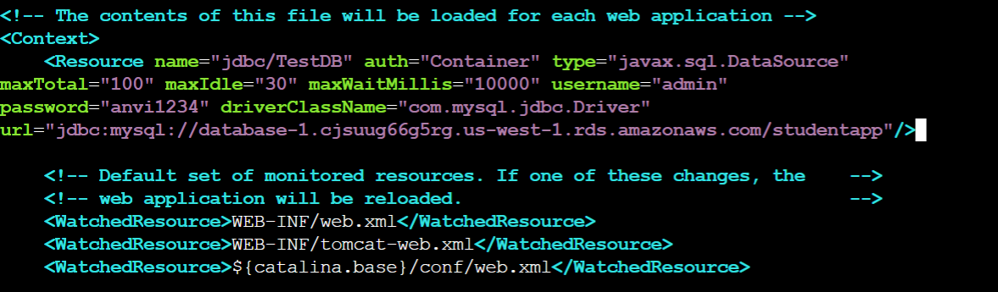
Step V : then Install the mariadb using “ yum install mariadb105 -y”.
5)Connect the Database
Step I : use the Command “mysql -h Endpoint -u username -ppassword;”.
Step II : once connected, then create a new database using “create database database_name;”.
Step III : Switch newly created database using “use db_name”.
Step IV : CREATE TABLE if not exists students(student_id INT NOT NULL AUTO_INCREMENT, student_name VARCHAR(100) NOT NULL, student_addr VARCHAR(100) NOT NULL, student_age VARCHAR(3) NOT NULL, student_qual VARCHAR(20) NOT NULL, student_percent VARCHAR(10) NOT NULL, student_year_passed VARCHAR(10) NOT NULL, PRIMARY KEY (student_id)
);
Add this script in it use exit command to exit form db.
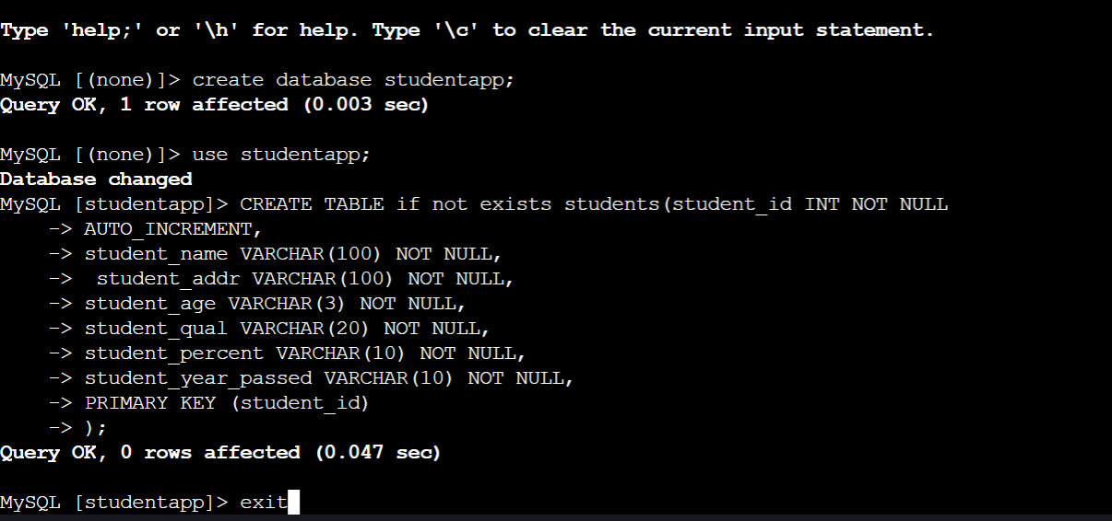
Step V : then Stop the catalina.sh using “./apache-tomcat-9.0.87/bin/catalina.sh stop”.
Step VI : add start again using “./apache-tomcat-9.0.87/bin/catalina.sh start”.
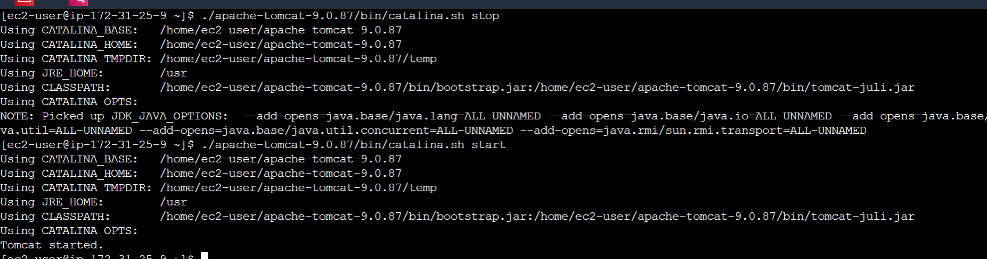
Step VII : see here data will be added successfully.
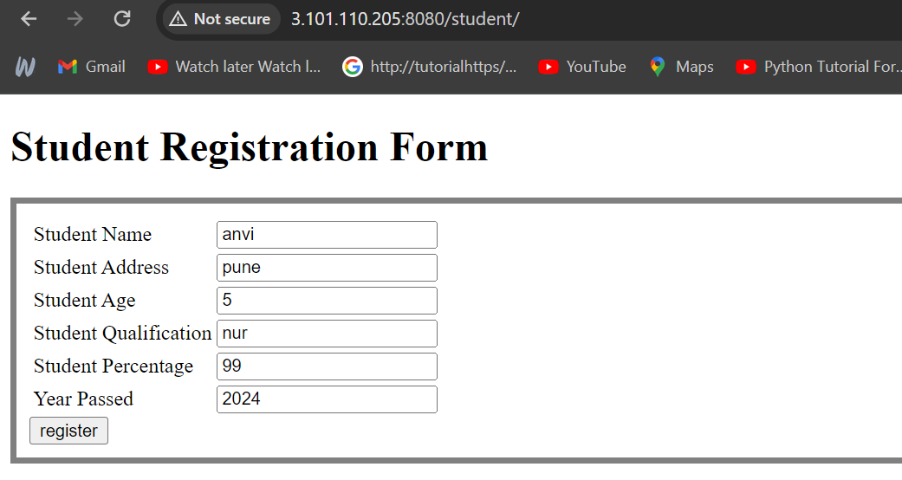
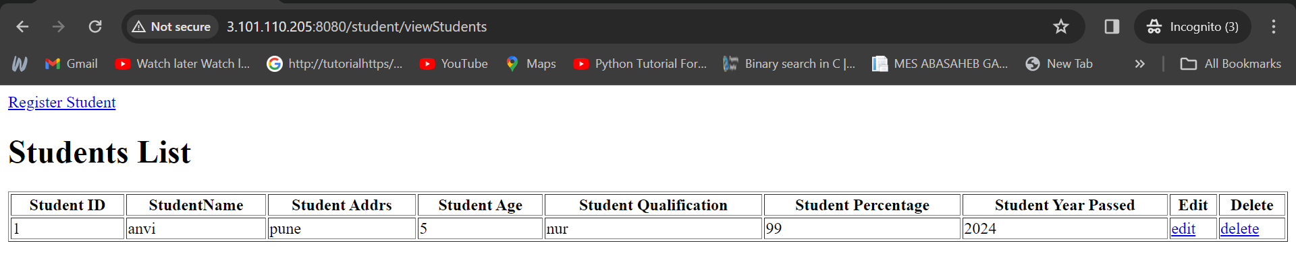
Creating the Proxy server.
Step I : Launch the new Instance add same security group as we added in above instance and also add http.
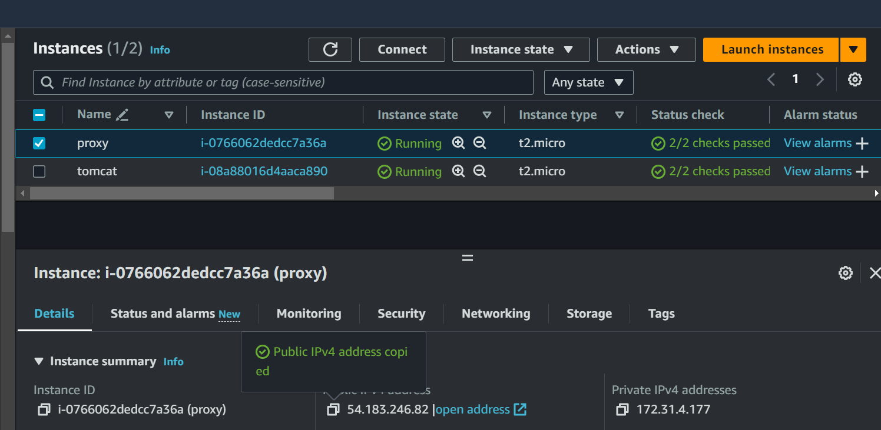
Step II : Connect the instance .
Step III : then Install nginx.
Step IV : using ls check the file in /etc/nginx.
Step V : then edit the configuration file type “vim /etc/nginx/nginx.conf”.
Step VI : In this, Add the application address in this file.
Location / {
Proxy_pass http: //ApplicationPublicIP:8080/student/;
}
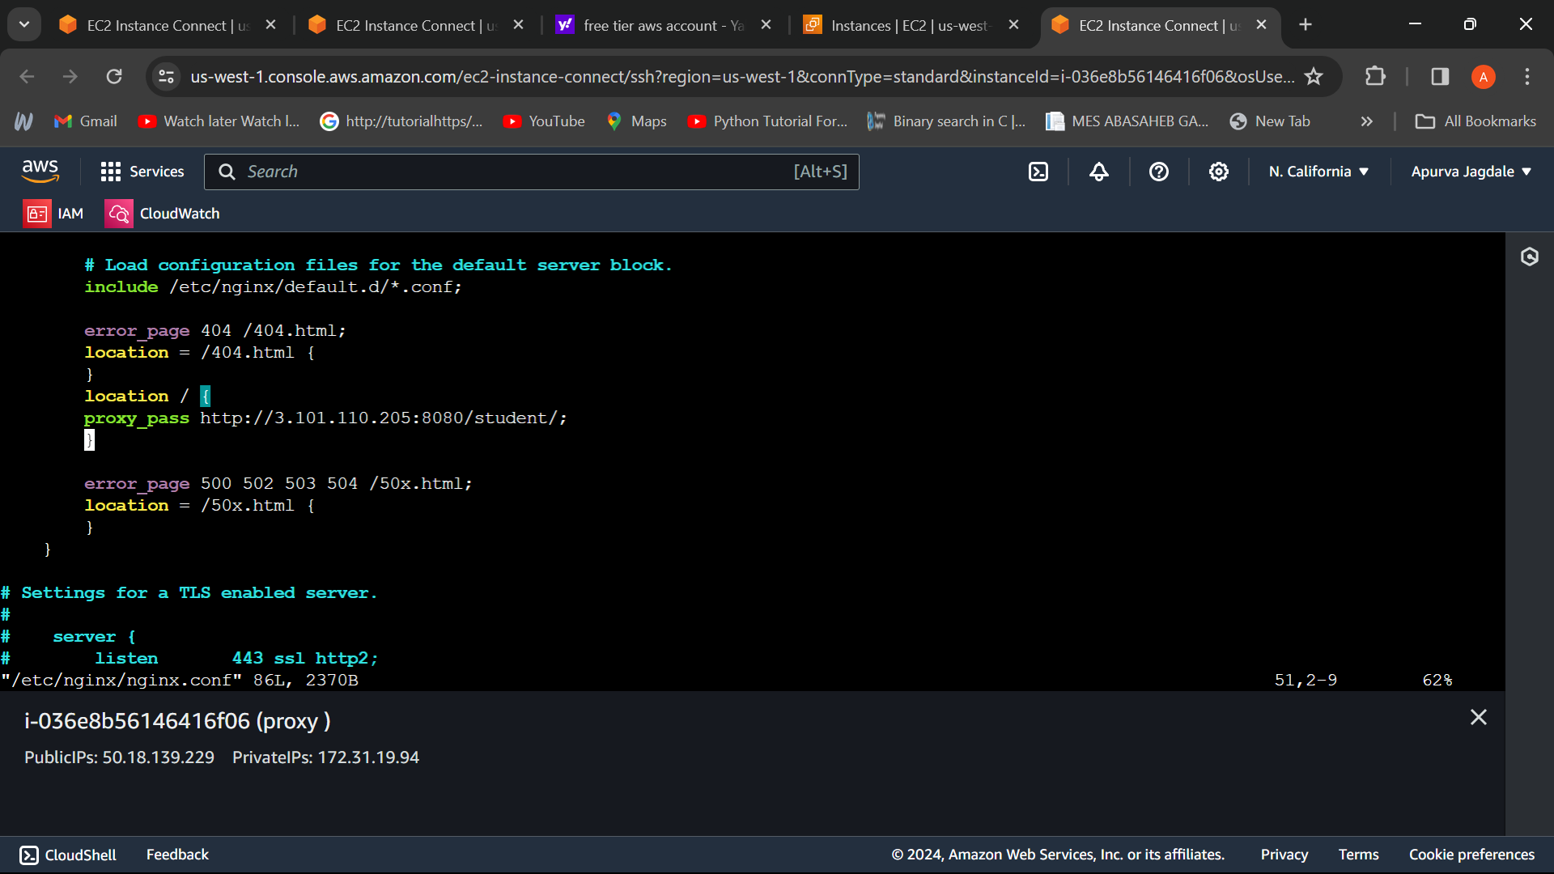
Step VII : then, Start the service using “systemctl start nginx” and enable it.
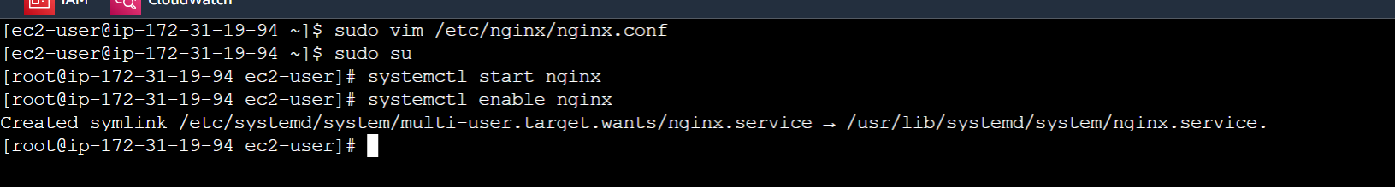
To Verify
Copy the public IP of proxy server instance and paste it in another browser.
After registering student see here it is added successfully.
